Title (Calibri, 12p, bold, centered)

List of authors (First name Last Name) (Calibri, 11 p, italic, centered)
Affiliations (Calibri, 11 p, centered)

Abstract (limited to 2 page including figure and table, Calibri, 11 p, justified)
Figures and tables captions and the references should be formatted as in this document. The multi-author paper by Tata and al. (2025) showed this, but that was also demonstrated elsewhere (see the two-author paper by Tata and Toto, 2025. See also Figure 1 and Table 1.
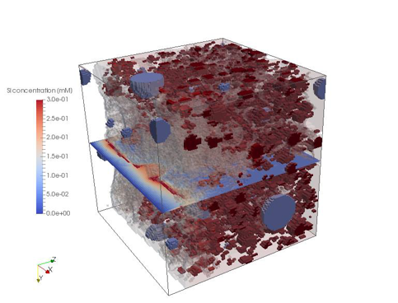
Figure 1: Figure captions should be below the figure (Calibri, 11 pp, italic, centered)

Table 1: Table captions should be above the table (Calibri, 11 pp, italic, centered)
A | B | C | D
1 | 2 | 3 | 4
5 | 6 | 7 | 8

Lorem ipsum dolor sit amet, consectetuer adipiscing elit. Ut purus elit, vestibulum ut, placerat ac, adipiscing vitae, felis. Curabitur dictum gravida mauris. Nam arcu libero, nonummy eget, consectetuer id, vulputate a, magna. Donec vehicula augue eu neque. Pellentesque habitant morbi tristique senectus et netus et malesuada fames ac turpis egestas. Mauris ut leo. Cras viverra metus rhoncus sem. Nulla et lectus vestibulum urna fringilla ultrices. Phasellus eu tellus sit amet tortor gravida placerat. Integer sapien est, iaculis in, pretium quis, viverra ac, nunc. Praesent eget sem vel leo ultrices bibendum. Aenean faucibus. Morbi dolor nulla, malesuada eu, pulvinar at, mollis ac, nulla. Curabitur auctor semper nulla. Donec varius orci eget risus. Duis nibh mi, congue eu, accumsan eleifend, sagittis quis, diam. Duis eget orci sit amet orci dignissim rutrum.
Nam dui ligula, fringilla a, euismod sodales, sollicitudin vel, wisi. Morbi auctor lorem non justo. Nam lacus libero, pretium at, lobortis vitae, ultricies et, tellus. Donec aliquet, tortor sed accumsan bibendum, erat ligula aliquet magna, vitae ornare odio metus a mi. Morbi ac orci et nisl hendrerit mollis. Suspendisse ut massa. Cras nec ante. Pellentesque a nulla. Cum sociis natoque penatibus et magnis dis parturient montes, nascetur ridiculus mus. Aliquam tincidunt urna. Nulla ullamcorper vestibulum turpis. Pellentesque cursus luctus mauris.

References
Reference style: (Calibri 10 p, justified
Up to two authors names and year of publication, More than two Tata et al. 1968
Tata, P.C., Toto, T., Tutu, F. 2025a. Smile for the picture. Journal of Structural Geology 26, 1400-1417.
Tata, P.C., Toto, T. 2025. Do not smile for the picture. Journal of Structural Geology 26, 1400-1417.

